**Uninstall Naplan Browser**

These steps can only be performed after you have exited the NAP Locked down browser.

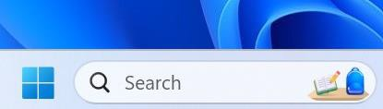

1

1. Select the **Windows** icon.

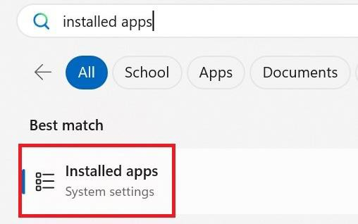

2

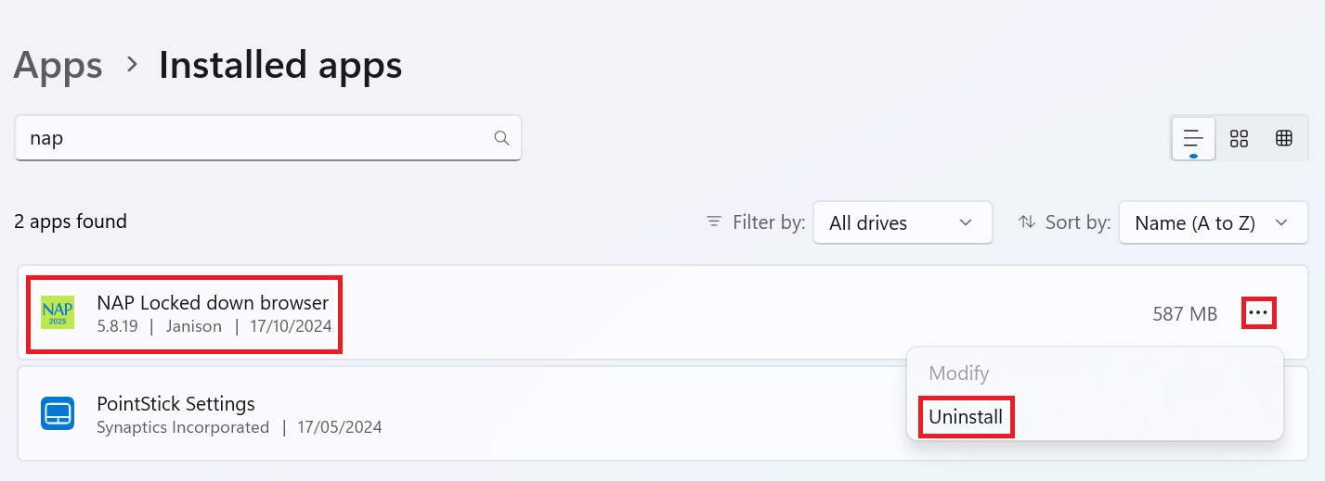

3

4

5

6

1. Search for ‘**Installed apps**’ and then select **Installed apps**.
2. Search for “NAP”
3. Select **NAP Locked down browser**.
4. Click on the **three dots** next to NAP Locked down browser
5. Select **Uninstall**
6. If you are presented with another popup asking you to confirm uninstall, select **Yes**.