How to install the NAPLAN browser

Click HERE to get to Go website and click on the “Software Installs and Help Documents” icon..
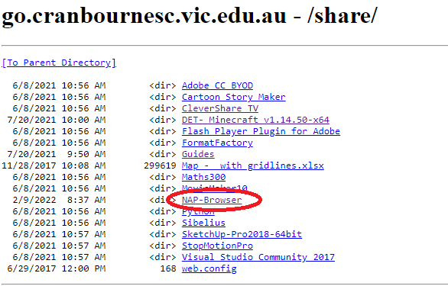

1 – Select the installer which matches the operating system you have. The Windows one is the most common or MAC version for Apple computers.

2 – Click the ‘accept’ check box and then the install button.
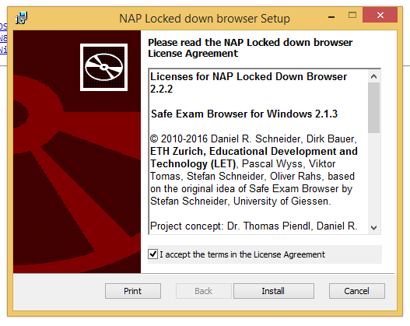

Ready to go……

