LanSchoolAir
Click the LanSchoolAir link on our ‘Go’ website.
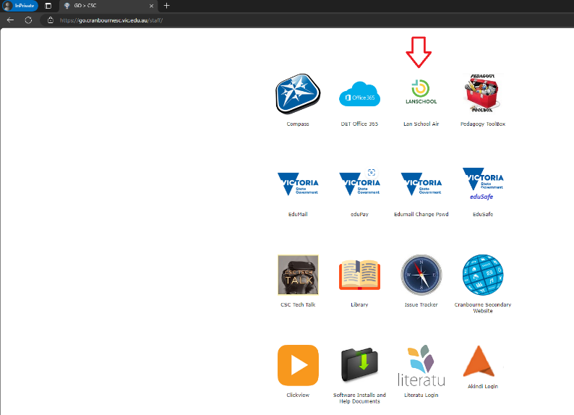

Your username is your timetable code plus @cranbournesc.vic.edu.au
Password is your laptop/Compass password. Just like for the library site.
For example CWA@cranbournesc.vic.edu.au
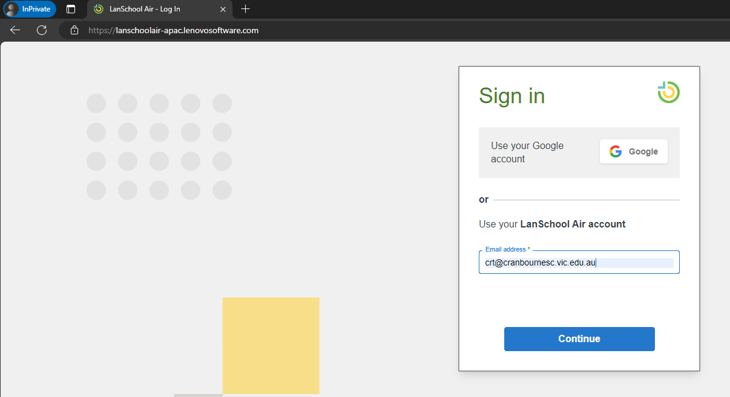

Once in you can create a class and add student devices to it.
The are written guides here:
https://helpdesk.lanschoolair.com/portal/en/kb/lanschool-air/using-lanschool-air-in-the-classroom
Video guides here:
https://www.youtube.com/@LenovoSoftware/videos
The students will start getting the LanSchoolAir app on their netbooks when they restart them at school. If they are having issues they will need to come to the IT Dept during the appropriate times.

