Connecting School devices to the eduSTAR wireless network .
Windows 10 Quick Guide | v1.0

Introduction
This quick-guide provides students, with instructions to self- connect Windows 10 School purchased devices to the eduSTAR.net wireless network.

Before you begin
Before following the instructions below: This is for Devices that have previously connected to School WIFI successfully and were school Purchased, (Not BYOD devices)..Make sure you are at school…..

Connecting to the eduSTAR wireless network

- Click the network access icon on the status bar to view wireless networks.
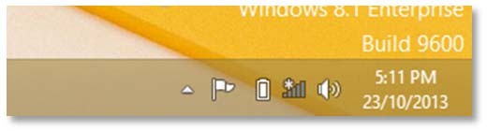

- 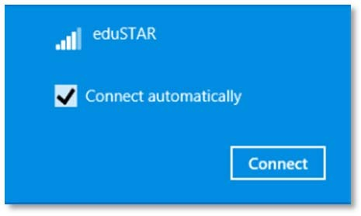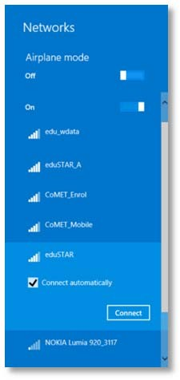The Computer will then show available wireless networks on the right side of your screen
Select the “eduSTAR” wireless network and click Connect

- Click OK

- A warning will now display, click Connect when prompted
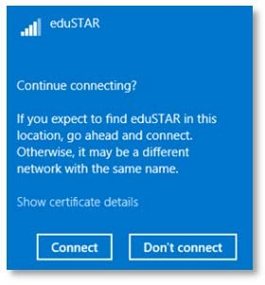

- Be patient while your credentials are verified

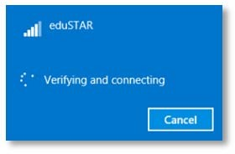

- After a few seconds your computer should connect to the wireless network
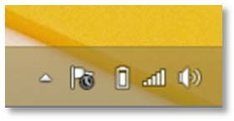

If not Students can contact their IT Support via the Admin Office during the Learning at Home Phase, otherwise when Learning from school come to IT office for Assistance during approved times.

2

