TO CONNECT TO SCHOOL WIFI

At the top right of screen check you have “WiFi” turned on…
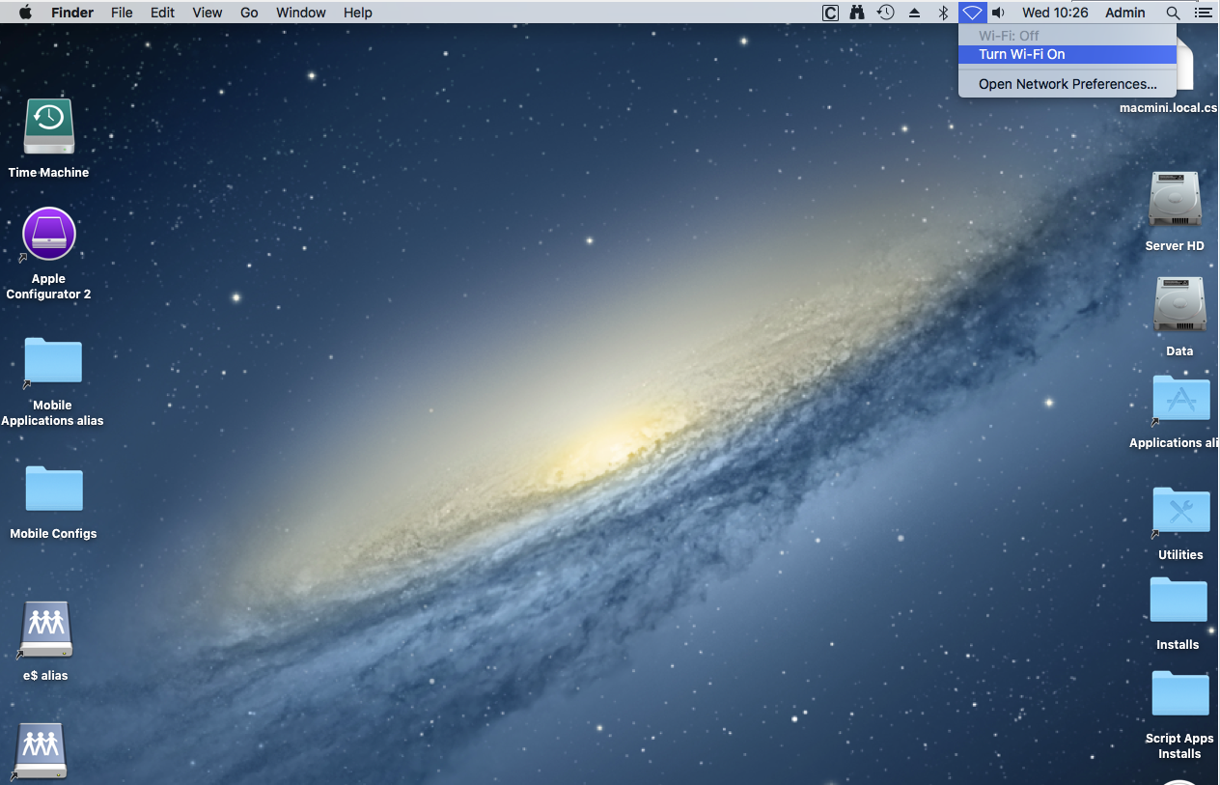

Then from the same icon select the “eduSTAR” WiFi network…
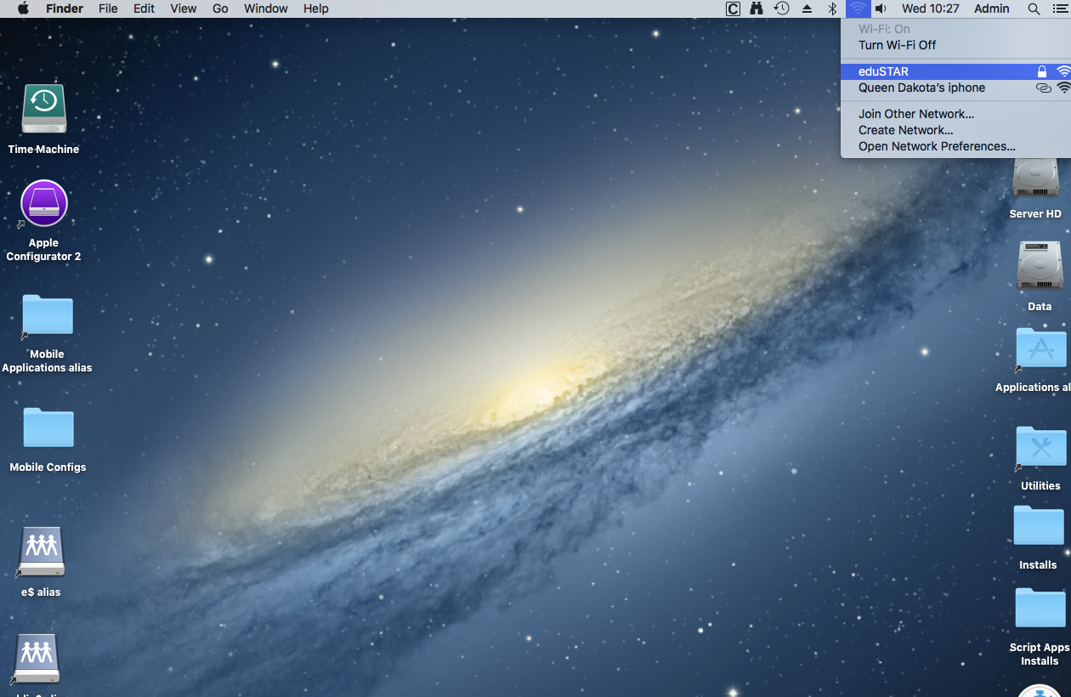

When the Logon box pops up enter your Credentials as “EDU002\’username’ and password and click join….if a box pops up about “Trusting a certificate” Always trust it and continue and you should connect. 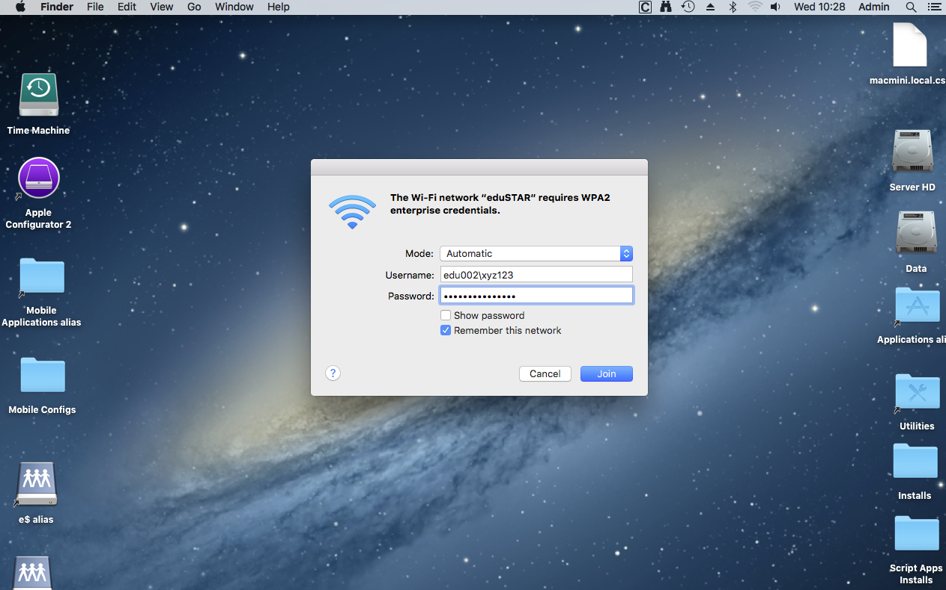
TO CONFIGURE PROXY FOR INTERNET USE
Open System Preferences …….
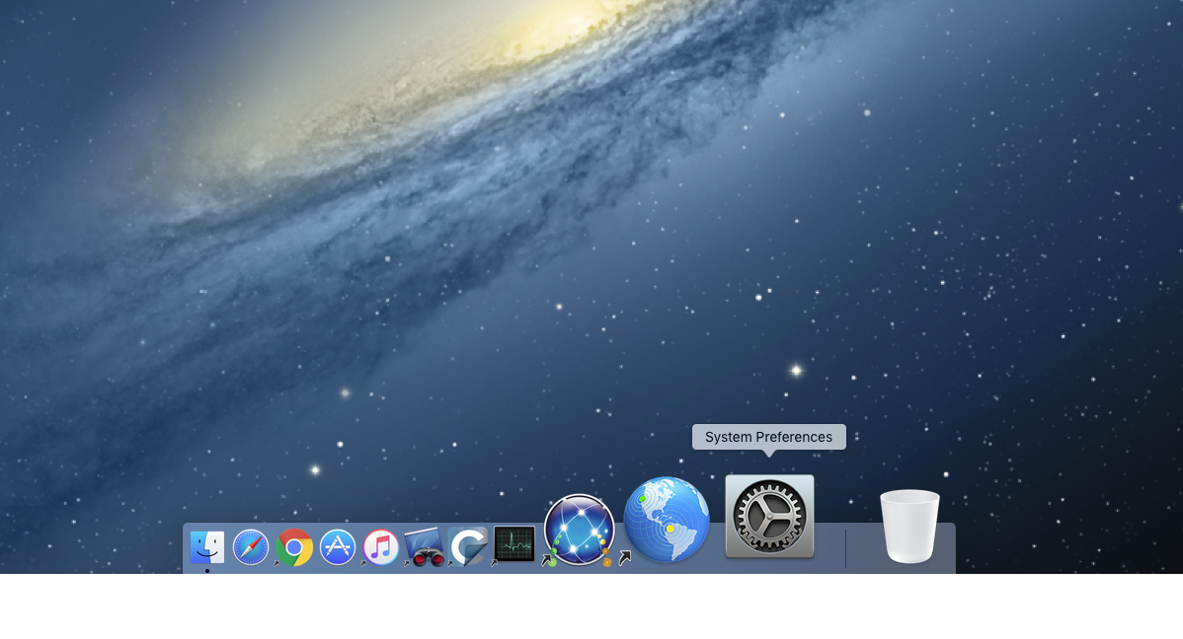

Then open the Network Icon…..
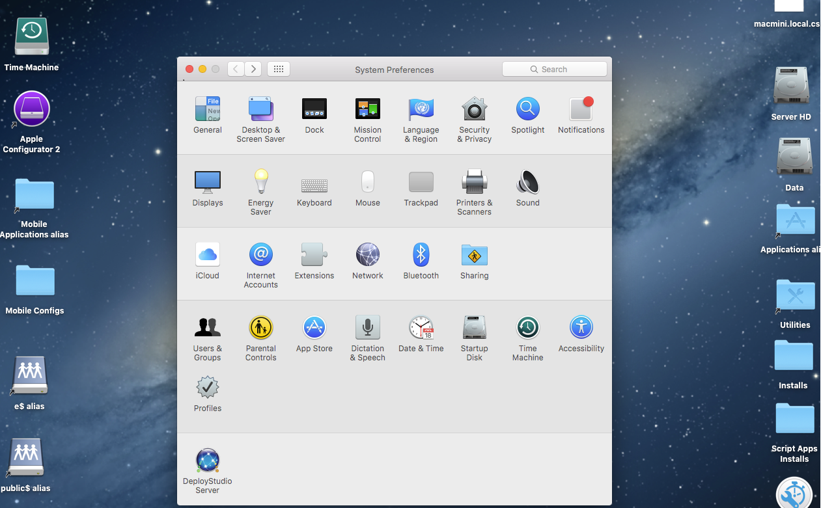

Then select the “Advanced” option…
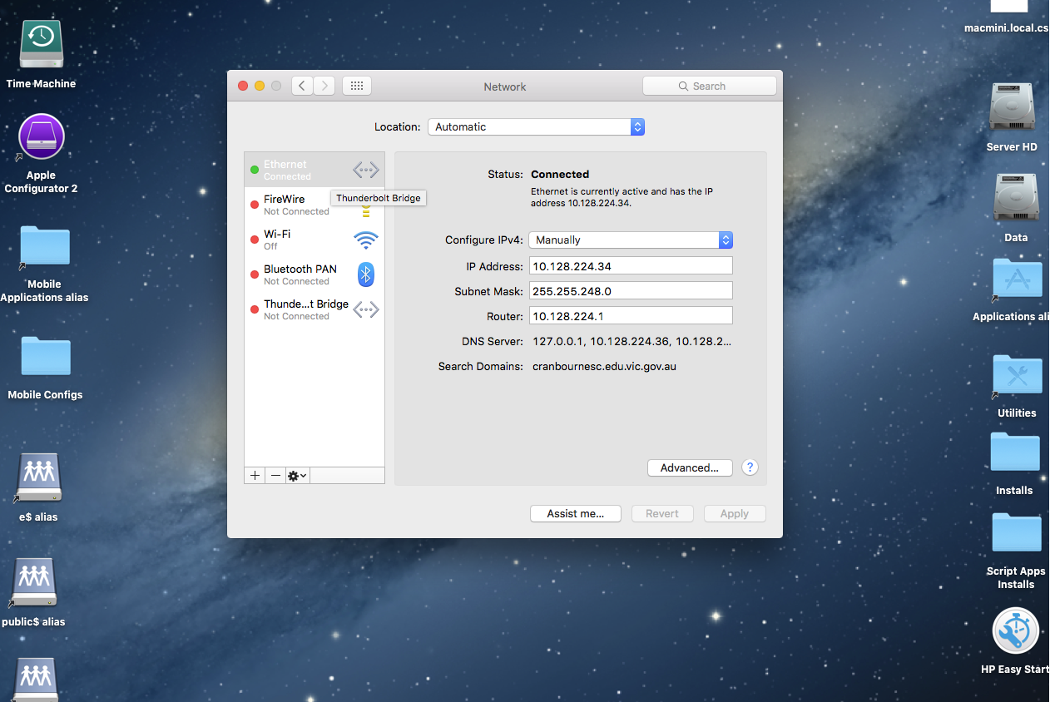

Then select the Proxies tab and check the “Auto Proxy Discovery” option… and you are done,
check you can access Internet ok.