First step is to setup your DET O365 Onedrive so it appears in your list of drives.
- Log into the DET O365 Website.
Students https://login.microsoftonline.com/?whr=schools.vic.edu.au
Staff https://login.microsoftonline.com/?whr=education.vic.gov.au
- Select Onedrive from the list of apps
- Press the ‘sync’ button.
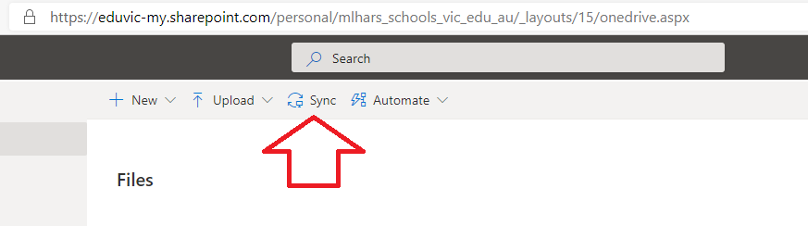
- Use your DET O365 account details when asked.
You will then see the DET Onedrive listed.
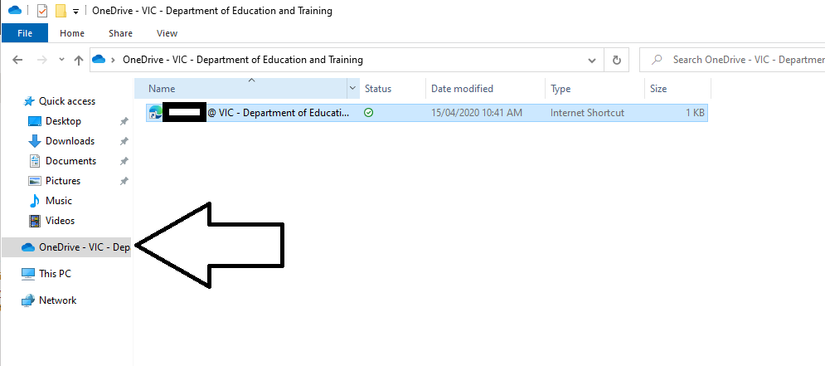

The next page will show you how to copy files to and from the Onedrive folder.

