**Printing on the School Network**

**for domain connected netbooks**

**(staff & students in Years 7 to 9)**

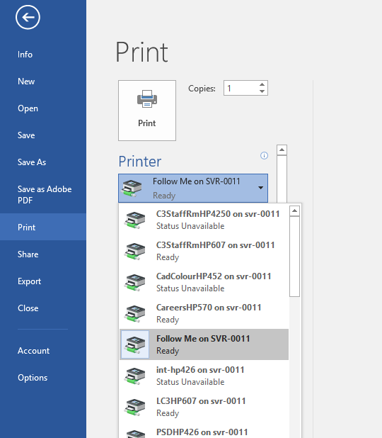

**Step 1**: Open the file you want to print in the appropriate App. (for example .docx in Word)

**Step 2**: Select your printer. (Follow-Me is for the Photo Copiers).

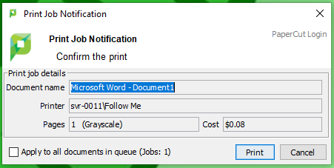**Step 3**: After you have told the computer to print to your chosen printer, you will receive a message on your computer screen. Follow the prompts and click the right buttons.

**Step 4**: Walk to the printer you have selected and collect your masterpiece.