Changed Library Login Method.
Staff you will now need to Login to the Library system (Infiniti) by using Single Sign On which requires using your school Email Address
E.G…smi@cranbournesc.vic.edu.au and your usual Compass password.
This email is only Used to logon to the Library system !!
You still use your “EduPass” Email to login to Office365 and Edustar apps, Edupay etc.
E.G john.smith@education.vic.gov.au
See Pic how to login to Library system via Microsoft Sign On….
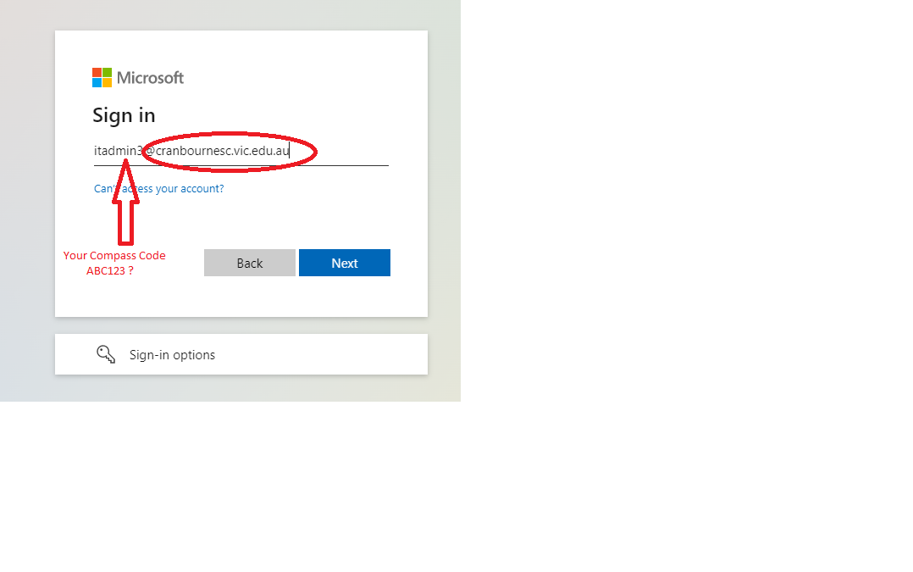
IMPORTANT !
Logging in using an incognito window is recommended or you should log out of the Library system when finished as if you login to Office365 while logged into the Library System it will log you in with the incorrect account in O365 …smi@cranbournesc.vic.edu.au not with your john.smith@education.vic.gov.au account)

Regards The CSC I.T Team
EXT 123

