On the “GO” Website select the “Printing Papercut” option…….

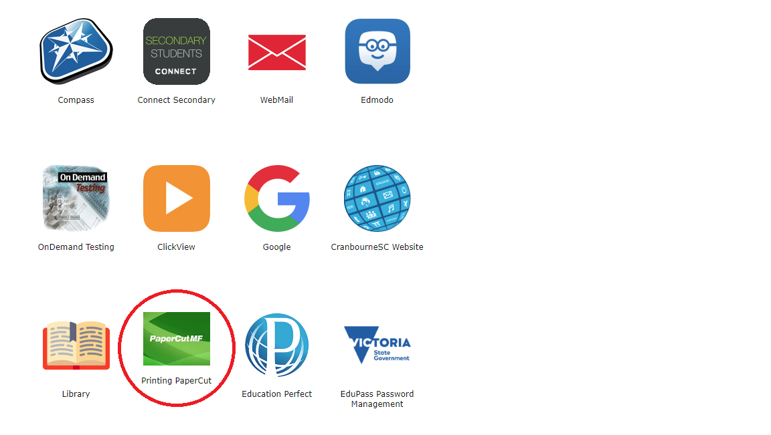

Login with your “School Account” credentials,
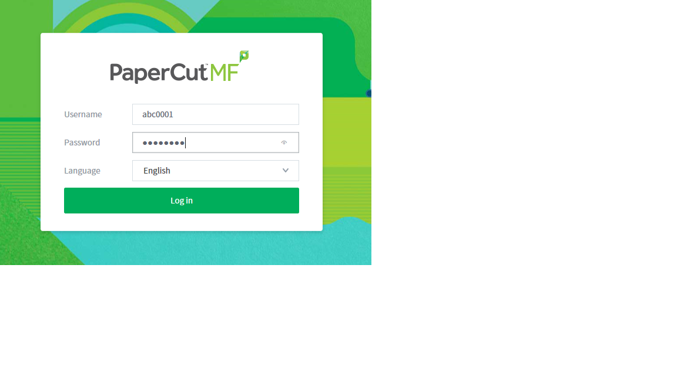

Select the “WebPrint” option.
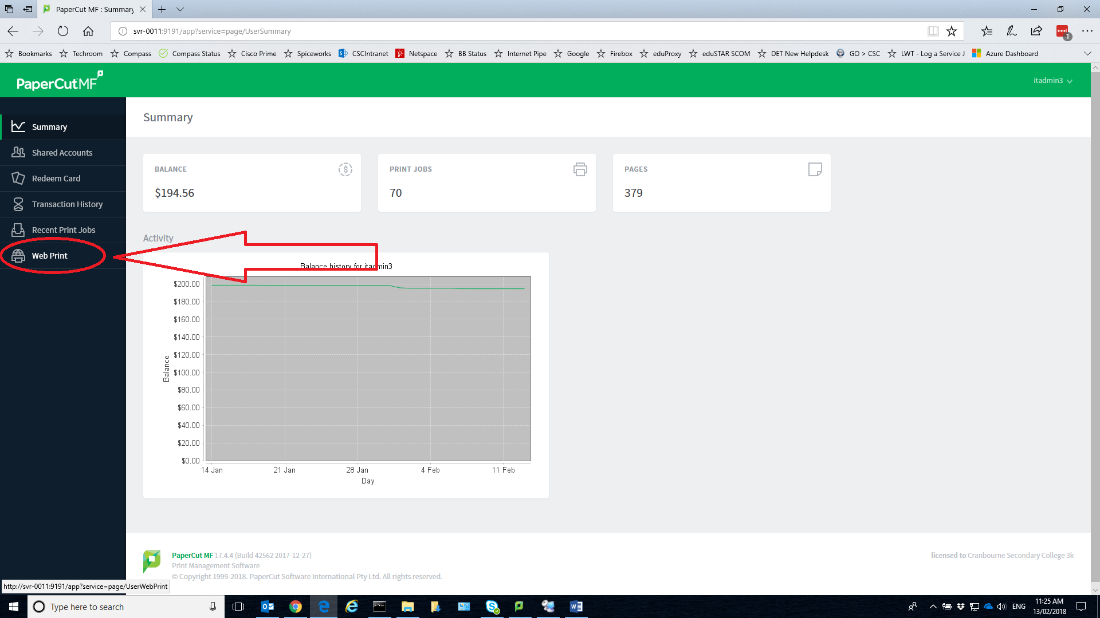

Select “Submit a Job”
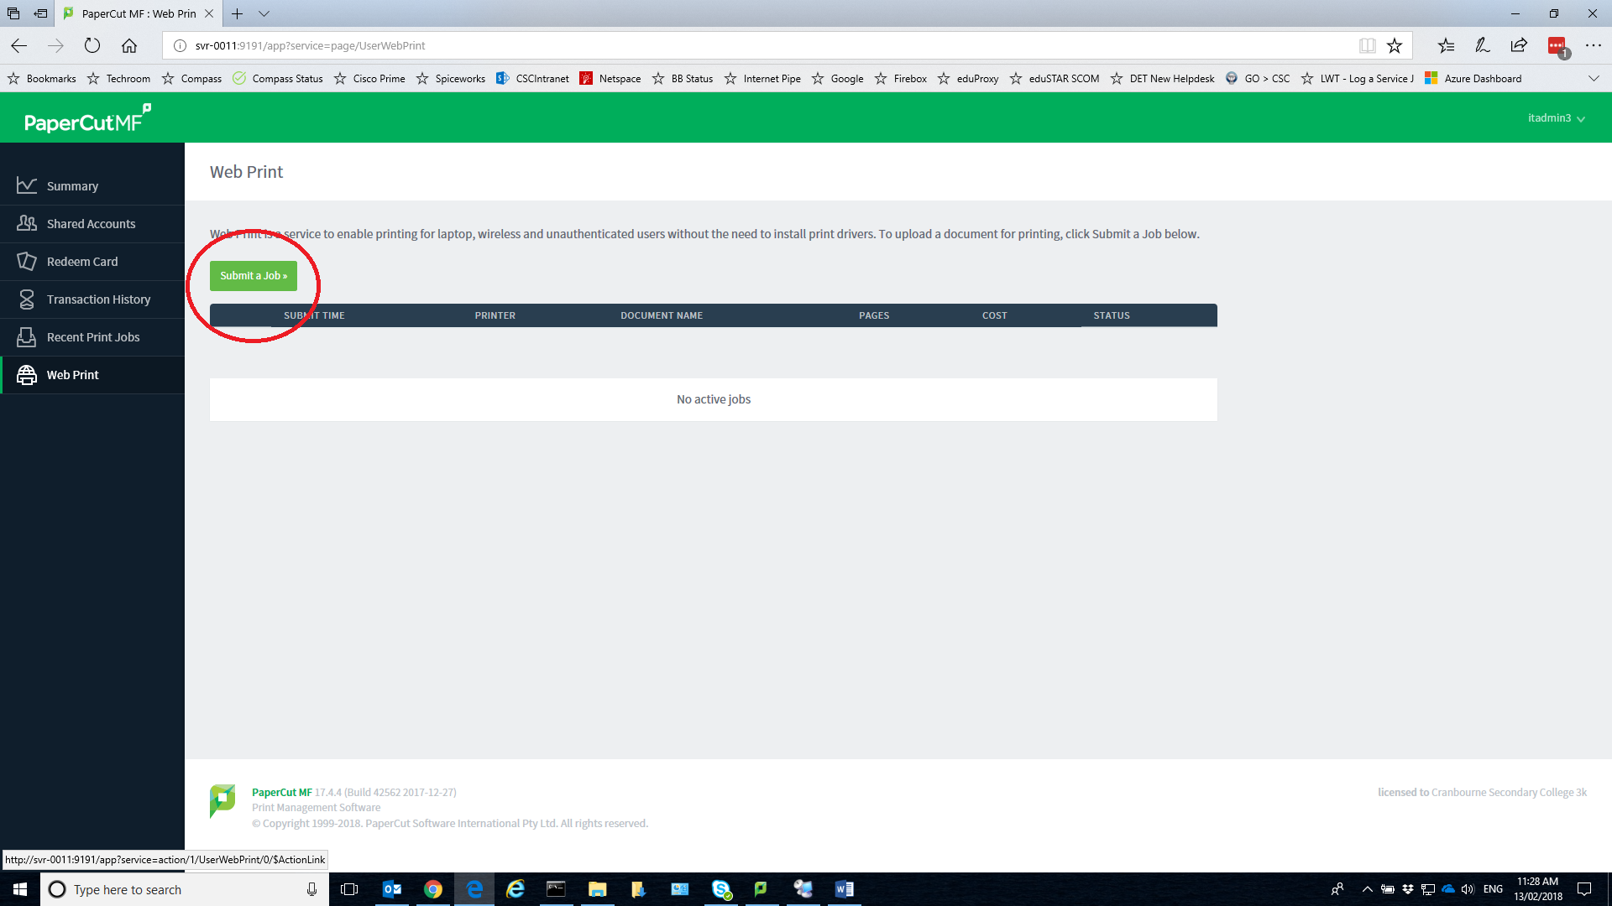

Select Print Queue you wish to use then select at the bottom “Print Options and Account Selections”
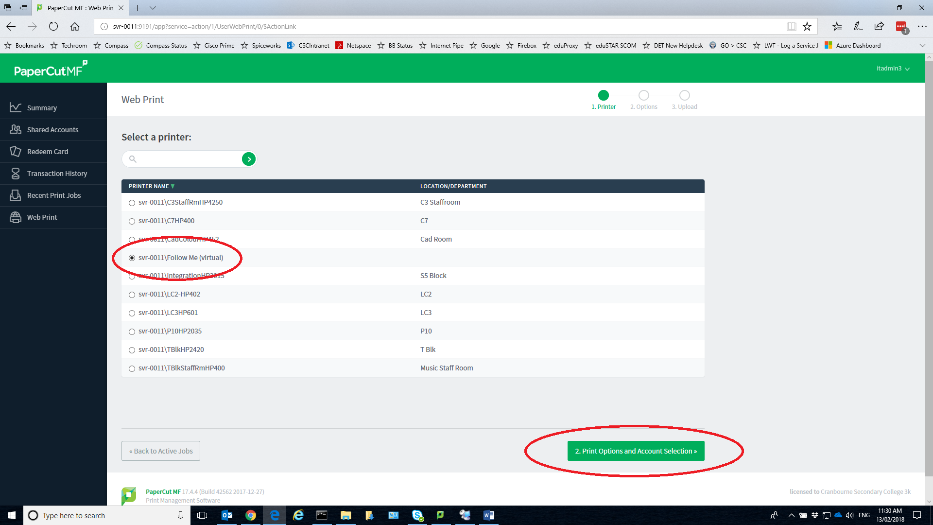

Select Upload and Complete…….
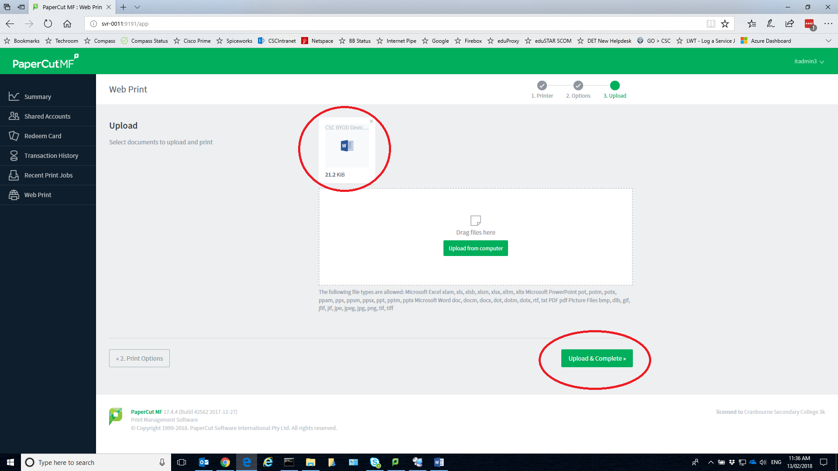

Your Documents will say Rendering then Queued, you can now go to the Copier and Login or swipe ID card to release print job from Queue and Select Job to Print it.
